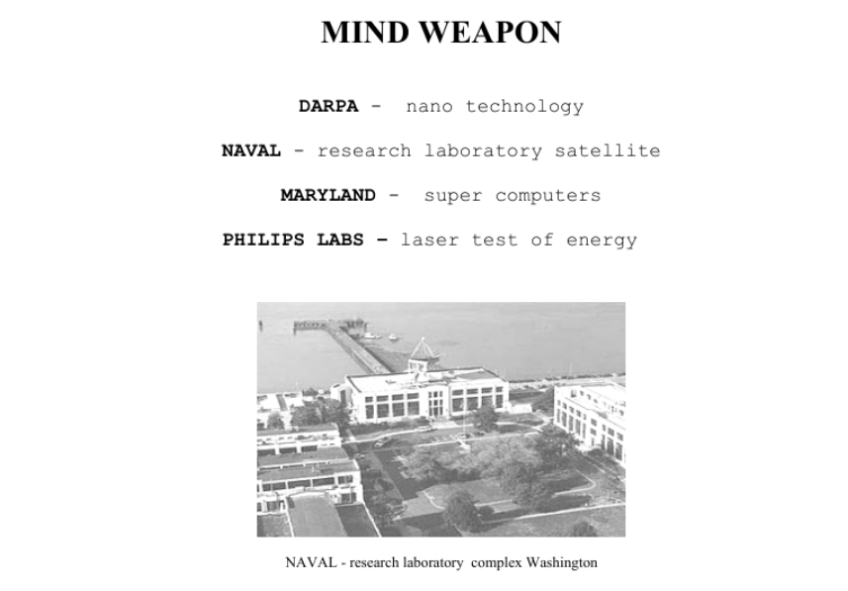
TABLE OF CONTENTS:
- 01. SATELLITE »MIND CONTROL« - BIOELECTRIC WEAPON
- 02. BRAIN-MACHINE INTERFACE
- 03. EUROPA - TARGETED INDIVIDUALS
- 04. SATELLITE SPIES – THE SHOCKING TRUTH
- 05. DIRECTED ENERGY PROFESSIONAL SOCIETY
- 06. A PILOT STUDY
- 07. PENTAGON HAVE LASERS THAT PUT VOICES IN YOUR HEAD
- 08. NANOTECHNOLOGY
- 09. MILITARY NANOTECHNOLOGY
- 10. NATO - THE SECURITY IMPLICATIONS OF NANOTECHNOLOGY
- 11. NANOTECHNOLOGY IN EUROPE
- 12. MILITARY SPACE PROGRAMS
- 13. SPACE WEAPONS
- 14. HUMAN RESEARCH PROTECTION PROGRAM
- 15. SCIENTISTS TO STUDY SYNTHETIC TELEPATHY
- 16. MURI - SYNTHETIC THELEPATY
- 17. 10 MODERN METHODS OF MIND CONTROL
- 18. SECRET TEST
- 19. NATO - GENOCIDE IN AFGHANISTAN
- 20. SYNTHETIC THELEPATHY - ALAN MILLER
- 21. BRAIN TRANSMITTERS
- 22. SECRET CODE OF THE BRAIN
- 23. NON-LETHAL WEAPONS - EUROPA
- 24. BIOEFFECTS OF NON-LETHAL WEAPONS
- 25. MORE INFORMATIONS OF MIND CONTROL
- 26. PROTECTION OF “MIND CONTROL”

