26.PROTECTION FROM MICROWAVES

1.Acrylic SRT-3 Q-Link
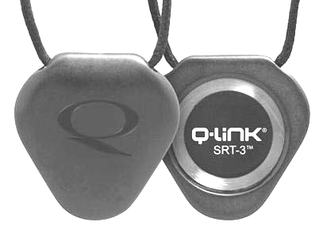
Sleek and chic, with a dual-tone design, this beveled-edge triangle has two distinct sides, each making a unique statement. It can be worn by both men and women as a signature piece, dressed up or down. Designed by internationally acclaimed designer Neville Brody and powered by our next-generation SRT-3, the result is leading-edge attitude and super-charged power.

2.QMX1 Defender
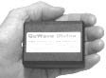
“Defense for Psychotronic Waves and Psychic Attacks” Scalar Field Frequency tuned to protect your body & brain from “Psychotronic Attacks“ from ELF, HAARP, Microwave, and Psychic Attacks. Converts electronic and psychic attacks to positive energy.

3.Killer Implant
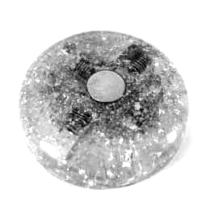
The implant killer was born out of a need to be able to eliminate nano-electronic implants placed illegally in our bodies by various government agencies and off-worlder entities. These implants control our behaviors, our state of mind, our moods, our energy levels, our ability to think abstractly and follow deeper lines of inner thought. They deplete our various systems, cause lesions and sores in the tissue and very often contain various nerve and protein coats, functioning as time bombs of death, through renal, kidney, and liver failure.

4.EARTHCALM - SCALAR HOME PROTECTION
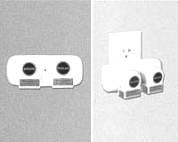
A powerful EMF protector that grounds you into the earth’s electromagnetic field—creating a sense of calm and peace throughout your home.The Scalar Home EMF Protection System utilizes the principles of cyclotronic resonance and scalar resonance.
junij 2011

